Milindi Shah J057

IOT Exp 10:

Programming with GPIOZero/any other library

Q1. Button controlled robot :

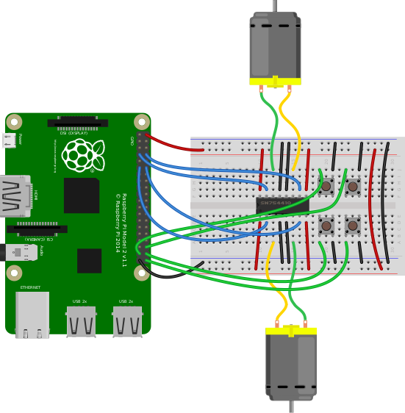

from gpiozero import Robot, Button

from time import sleep

from signal import pause

robot = Robot(left=(1,2), right=(3,4))

btn1 = Button(5)

btn2 = Button(6)

btn3 = Button(7)

btn4 = Button(8)

btn1.when_pressed = robot.forward()

btn1.when_released = robot.stop()

btn2.when_pressed = robot.left()

btn2.when_released = robot.stop()

btn3.when_pressed = robot.right()

btn3.when_released = robot.stop()

btn4.when_pressed = robot.backward()

btn4.when_released = robot.stop()

pause()

Q2. Make a robot drive forward when it detects motion :

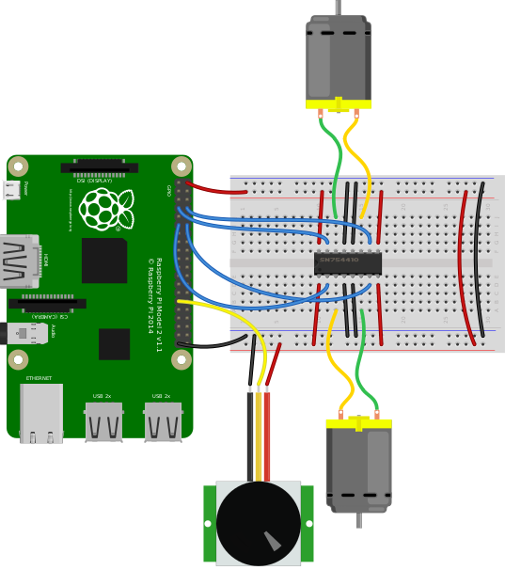

from gpiozero import MotionSensor, Robot

from signal import pause

robot = Robot(left=(1,2), right=(3,4))

pir = MotionSensor(6)

pir.when_motion = robot.forward()

pir.when_no_motion = robot.stop()

pause()

Q3. Present the value of a potentiometer on an LED bar graph using PWM:

from gpiozero import LEDBarGraph, MCP3008

from signal import pause

graph = LEDBarGraph(5, 6, 13, 19, 26, pwm=True)

pot = MCP3008(channel=0)

graph.source = pot

pause()

### Q4. Internet connection status indicator:

from gpiozero import LED, PingServer

from gpiozero.tools import negated

from signal import pause

green=LED(1)

red=LED(2)

internet = PingServer(‘google.com’)

green.source=internet

red.source=negated(green)

pause()

Q5.You can read the Raspberry Pi’s own CPU temperature using the built-in CPUTemperature class, and display this on a “bar graph” of LEDs:

from gpiozero import CPUTemperature, LED

cpu=CPUTemperature(min_temp=50, max_temp=90)

led=LED(1)

led.source=cpu